思路：

## Inspiration

While searching ideas of our project, some serious incidents caught in the eyes of us. One of the severe disasters is the one that happened in Hunan Province, China. It mainly is about the leaking of heavy metal ions in Xiangjiang River and the Huaihe River. The arsenic content of the main contaminated areas exceeded 715 times at maximum, and the ${Cd}^{2+}$ content exceeded 206 times at maximum.

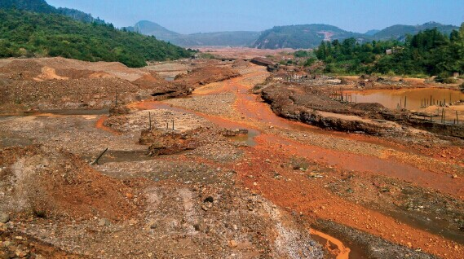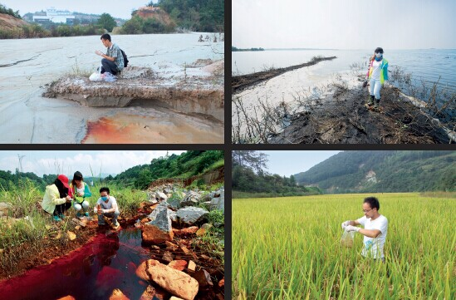

In thirty-six Bay mining area of Chenzhou, Hunan Province, arsenic content of Ganxi River sediment exceeded 715.73 times. In Ganxi village’s paddy field, ${Cd}^{2+}$ content exceeded 206.67 times. The highest content of ${Pb}^{2+}$ in paddy field reached to 1527.8mg / kg (that is per kilogram containing 1.5 grams), exceeding 5.093 times.

## Looking for help from Government

After noticing the repeated pollution incidents, we began to do some survey to find out whether the heavy metal pollution incident is particularly prominent not only in China but also all over the world. So we began to evaluate the meaning of our project. First, we started from China.

We visited the Chinese Ministry of Environmental Protection which is the **highest environmental protection departments** in China. We asked them how serious the heavy metal pollution is in China now. The Vice Minister of Environmental Protection of China told us that the part of Yangtze River near the coast, which has the water of the best quality in our seven major river systems has been affected by heavy metal pollution including Cd, Cu and Pb. And in the 21 cities along the river, six cities' percentage of heavy metal pollution accumulation has reached 65%.

## Set up an alliance

Since serious pollution problems had brought up, we decided to do something. To gather all the forces together for more information and more power, we established the China Heavy Metal Pollution Research and Investigation Alliance, which consists of SJTU / SCUT / XMU / UCAS / JLU / FAFU.

Those are teams that involved in researchers about water pollution or heavy metal pollution treatment in China. We discussed ideas and achievements of our own teams together, and we hope to build a database by cooperating with each other, which contains data of heavy metal pollution

(放地图)

From the pollution map we can see the following:

1,The pollution in Asia, Africa and Latin America is more serious in the United States and Europe: Although we don’t have comprehensive data for Africa and Latin America, but still can find this phenomenon.

2, the distribution of pollution is not uniform or normal, but most of the region at a good level of the environment at the same time, there are some serious polluted areas.

3, many countries and regions are still lack of investigation of copper and cadmium pollution and supervision, so there may be more areas of serious copper and cadmium pollution.

4, for our project, our work is of high social value, on the one hand, for the existence of the world's serious copper and cadmium pollution situation, our project can provide a viable solution and ideas. On the one hand, while some areas are seriously polluted, other regions even ignore the investigation of copper and cadmium pollution. Our projects can, to a certain extent, contribute to the attention of these countries for copper and cadmium pollution

Through the mapping of copper and cadmium pollution in the world, we understand the pollution of copper and cadmium around the world, but because of constraints ofour team’s human resourse and time, the world copper and cadmium pollution map has a lot of room for improvement, we sincerely hope and welcome other teams to participate in this work.

At the same time we would like to be able to play our own efforts to hold some science popularization activities, which aims to attach importance to the issue of heavy metal pollution. In order to be able to make a real and effective database containing heavy metal pollution data around the world, we also launched an invitation on the official website of collaboration, called for more iGEM teams to join our alliance or to provide some data and information. As a result, we received mails from iGEM EXETER, iGEM CSMU X NCHU TAIWAN and Nazarbayev University, and Exeter provided us with European data and shared their own protocol with us.

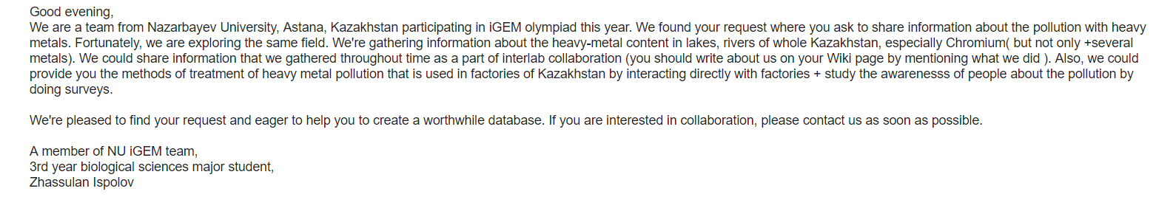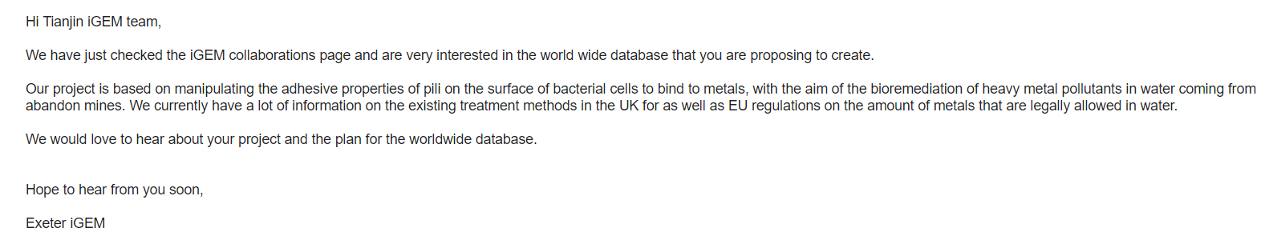

Besides, CSMU X NCHU TAIWAN provided us with statistical information on heavy metal pollution in Taiwan and listed the major pollution incidents in Taiwan in recent years for us.

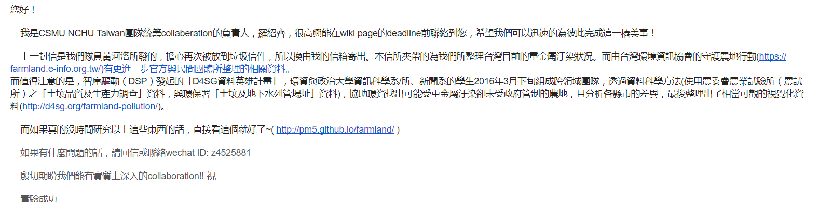

According to the results provided by the database, by using the alliance’s forces, we speared the questionnaire designed by us about the situation of heavy metal pollution throughout the country, and in the end we received nearly 1,000 replies.

## Consultation in many ways

In this situation, we consulted Professor Qu Hongyan who works at the School of Environmental Sciences at Tianjin University. He told us that the study of heavy metal removal from groundwater is a very important subject that still needs to be studied. It is of great value to use micro-organisms in heavy metal removal. So we decided to focus our project on heavy metal treatment and on treatments of cadmium and copper due Severity of pollution. Then, we learned that recently the heavy metal deposition research center in Hunan has made a great breakthrough. So we held a telephone conference to communicate with their technical teacher. During the conference, we asked the current situation about heavy metal pollution, and consult their approach to chromium ions sedimentation. That is turning high-valent chromium into low-valent chromium to reduce toxicity. This inspired us to think about if there is any better way to completely settle the chrome ions from the water.

## Searching the source of pollution: electroplating factory, electric drill factory

Because our experiment needs to design for the actual problem in our life, at the start, we left school for the electroplating factory in Shanxi Province and electric drill factory in Henan Province.

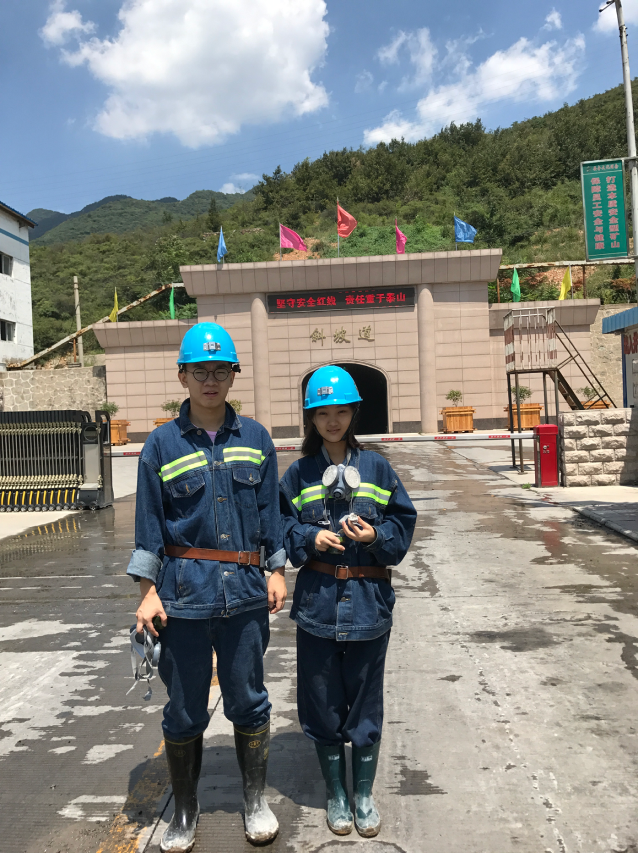

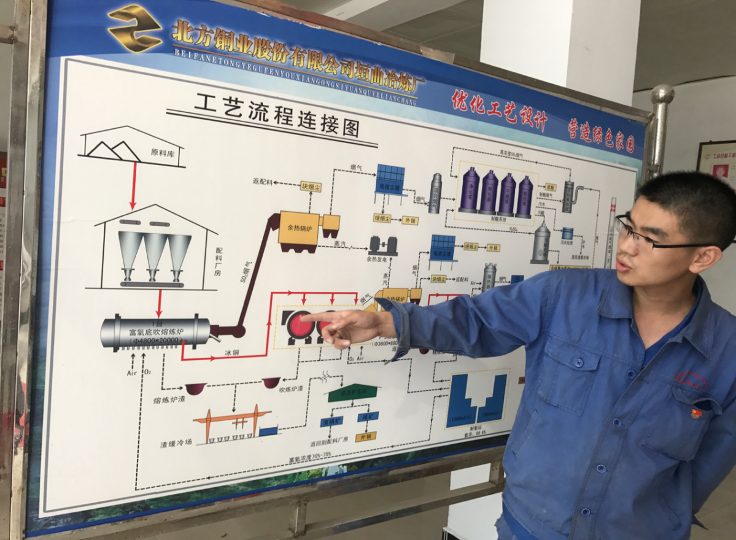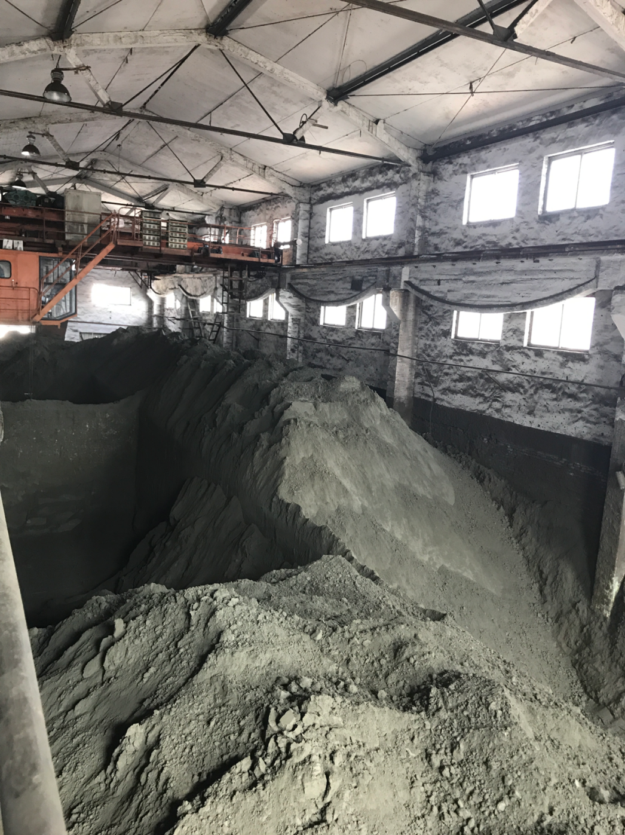

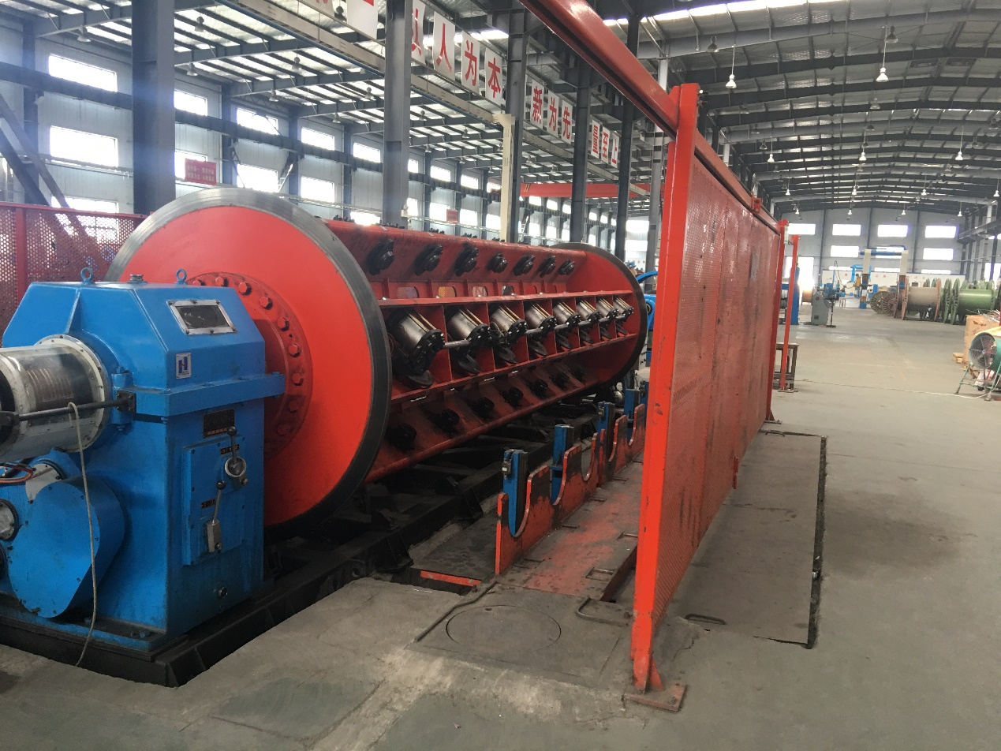

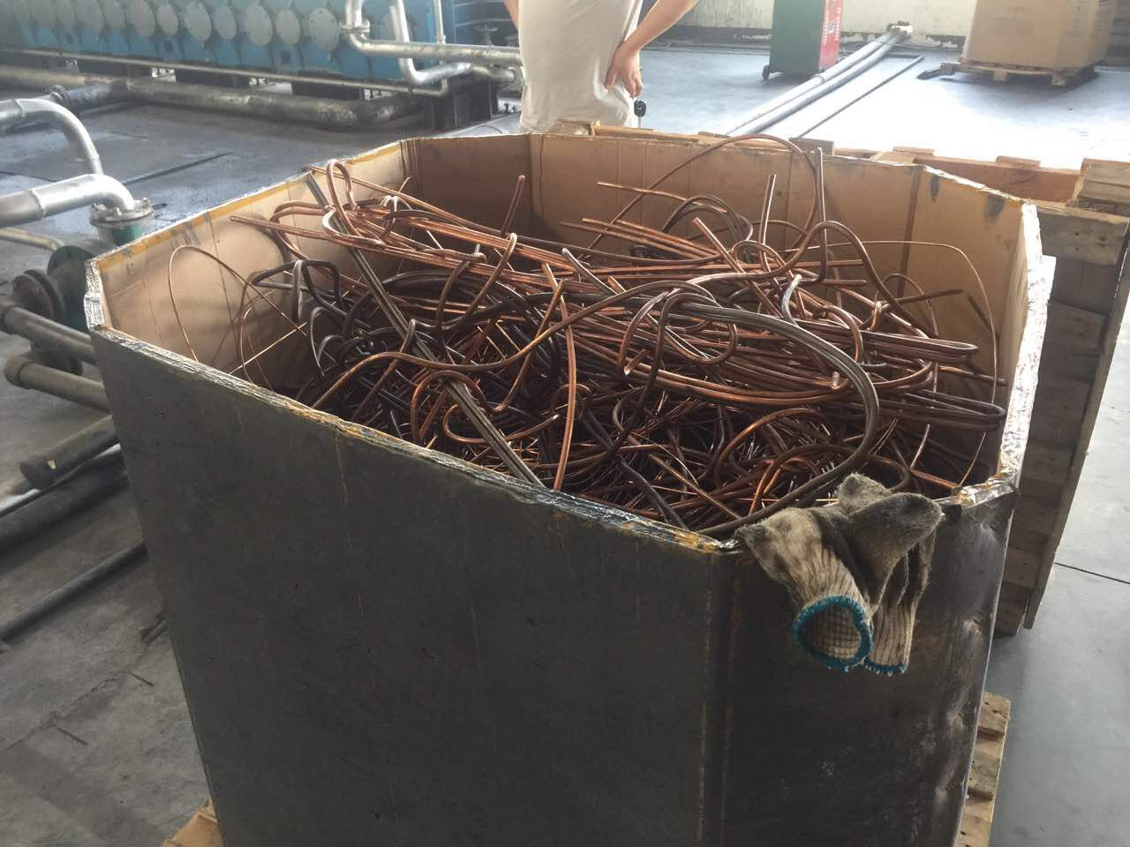

The electroplating factory mainly produces copper and cadmium ion while the electric drill factory mainly produces cadmium and nickel. They proposed that different heavy metals are treated by different methods. 90% of the treatment is chemical methods while 10% is biological methods. But most of time, in order to deal with that two kinds of heavy metals, some factories tend to use simple and quick ways which can be harmful to the environment.

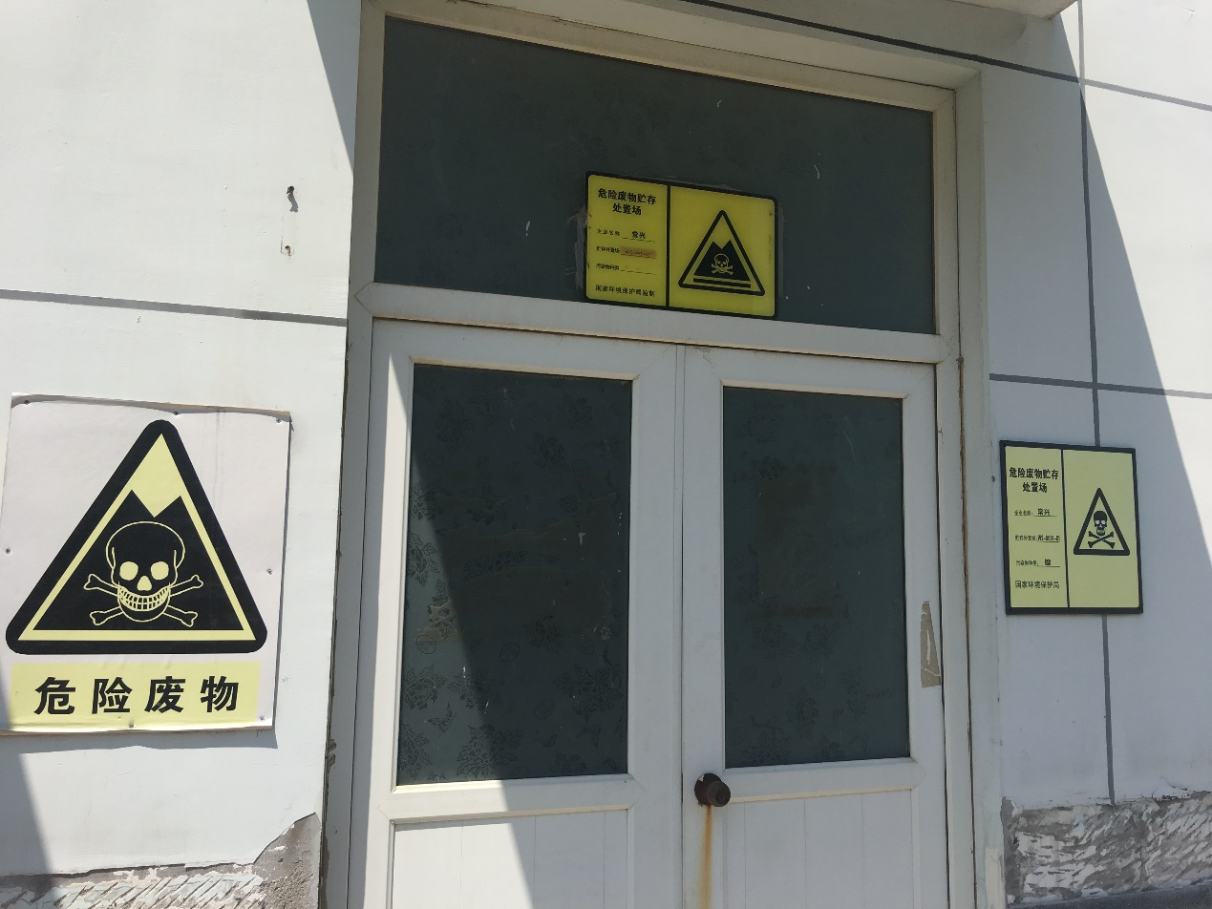

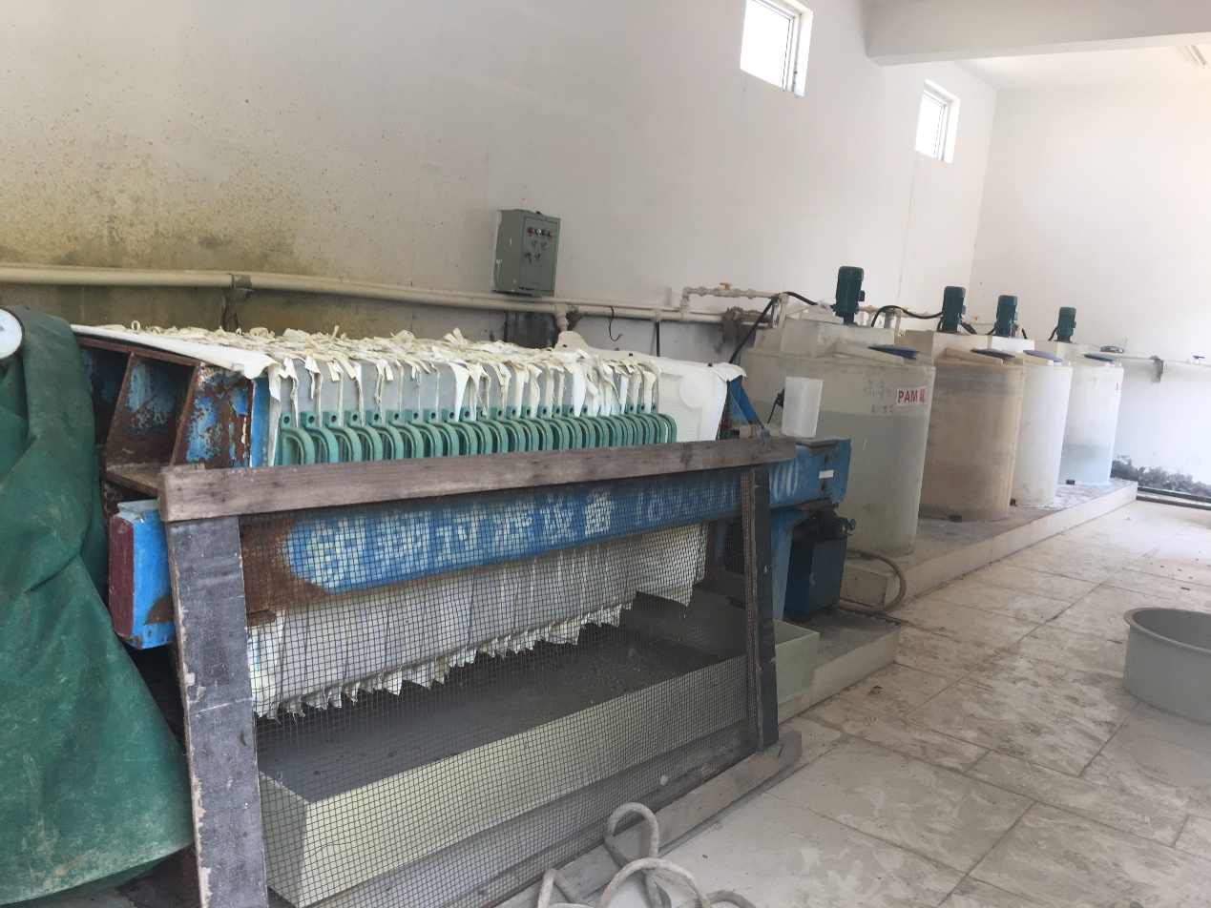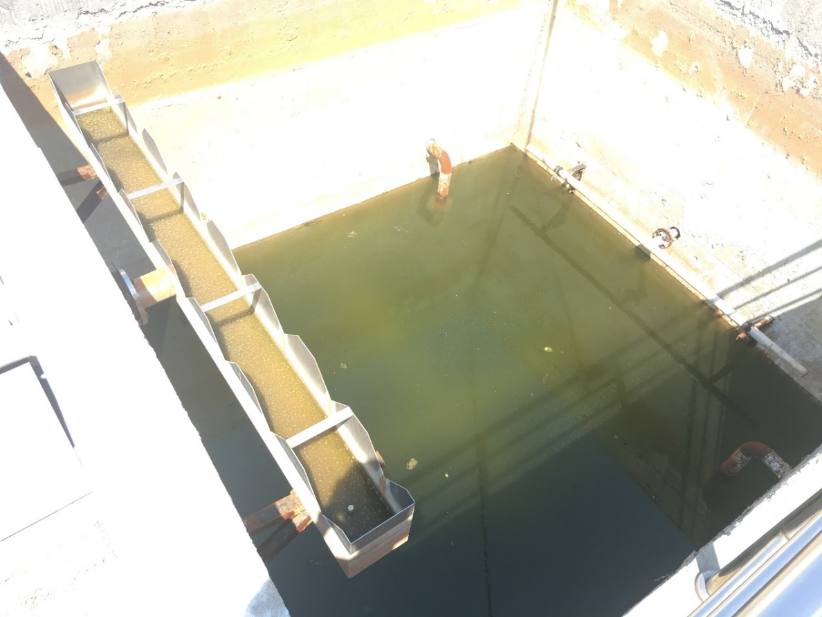

**Waste liquid from chemical treatment**

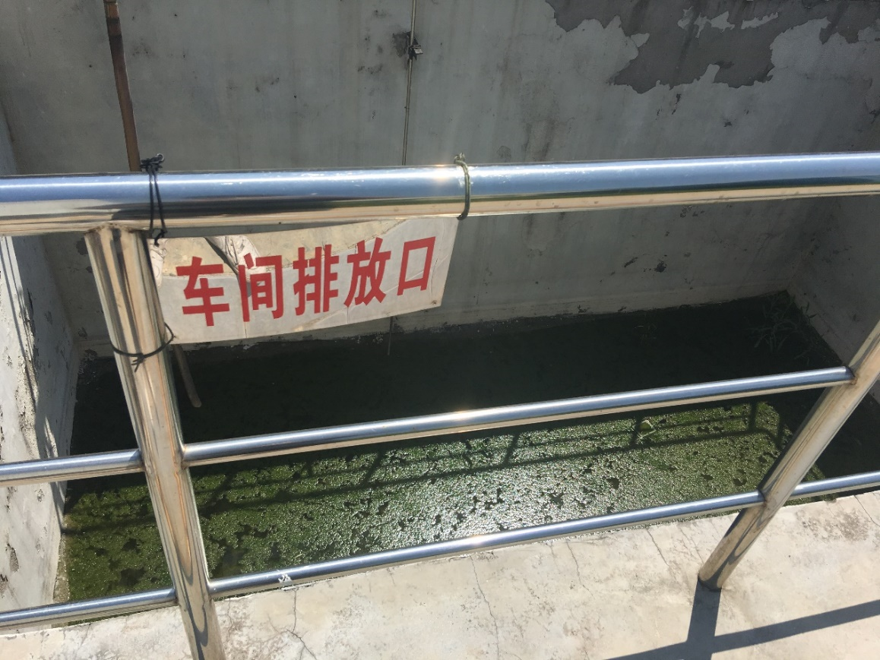And some of the factories directly choose to only deal with one kind of the heavy metals that has a larger amount, then abandon another kind of heavy metal without treatment. Based on the current situation that the treatment for a variety of heavy metals are not well developed, the issue about how to deal with a variety of heavy metals contained in polluted water has been considered as the primary problem, we hope to use a bacterium to collected two metals separately in different periods.

**Waste liquid from chemical treatment**

In order to deal with this problem, we put forward to a method named mating switcher, using the natural function of Saccharomyces cerevisiae. We hope to use the gender transition of Saccharomyces cerevisiae to realize the transition of function to we can settle different kinds of heavy mental step by step.

## Seek advice by communication with other teams

After those surveys, we had a meeting with Professor Zhang Haoqian and the leader Zhang Yihao from Peking team of Peking University. They expressed a keen interest in our team's mating switcher, and pointed out the defects of our experiment: 1. How can we improve the specificity of yeast to absorb heavy metals? 2. How to separate these two metals?

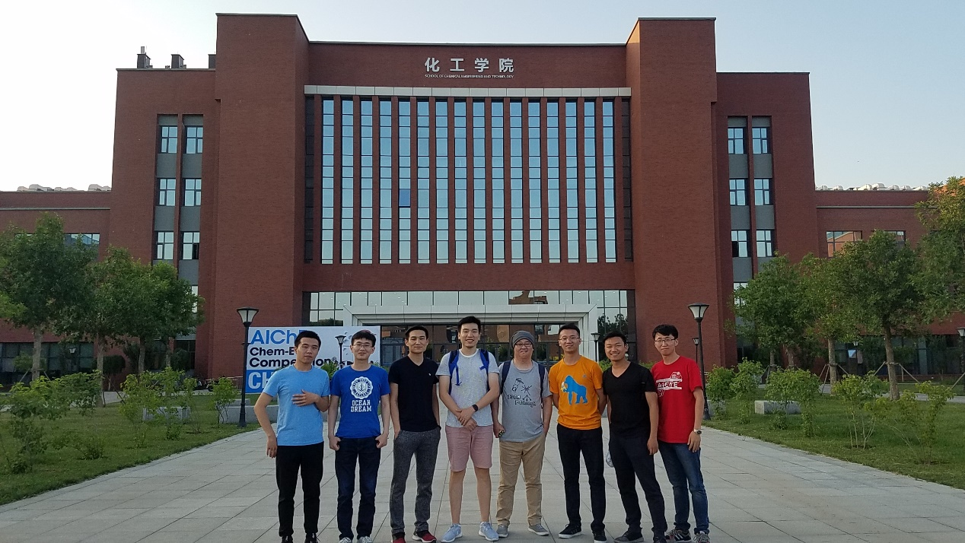

## Detection problems: domestic sewage treatment plant

With some problems to solve, we went to the domestic sewage treatment plant of Wugang City, Henan Province. The processing plant is representative, but we found that as a demonstration unit of the sewage treatment plant, they did not detect heavy metal ions usually. Only when the heavy metal content exceeded standard emissions, the information can be transferred to the Environmental Protection Agency. Thus, there exists two problems. 1.Domestic sewage treatment plant does not have its own set of detection system. 2. Once the heavy metal content exceeded, there is no corresponding solution.

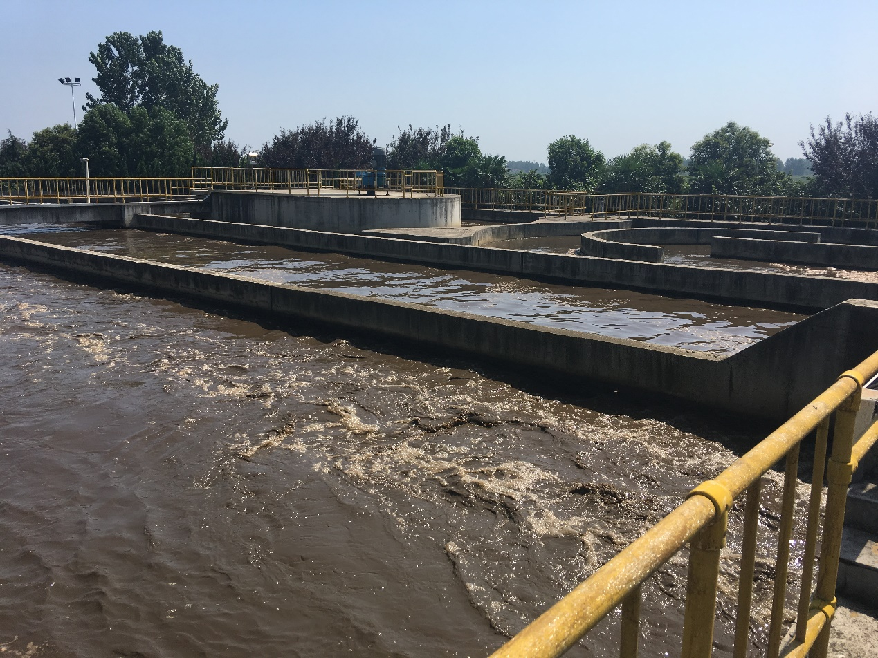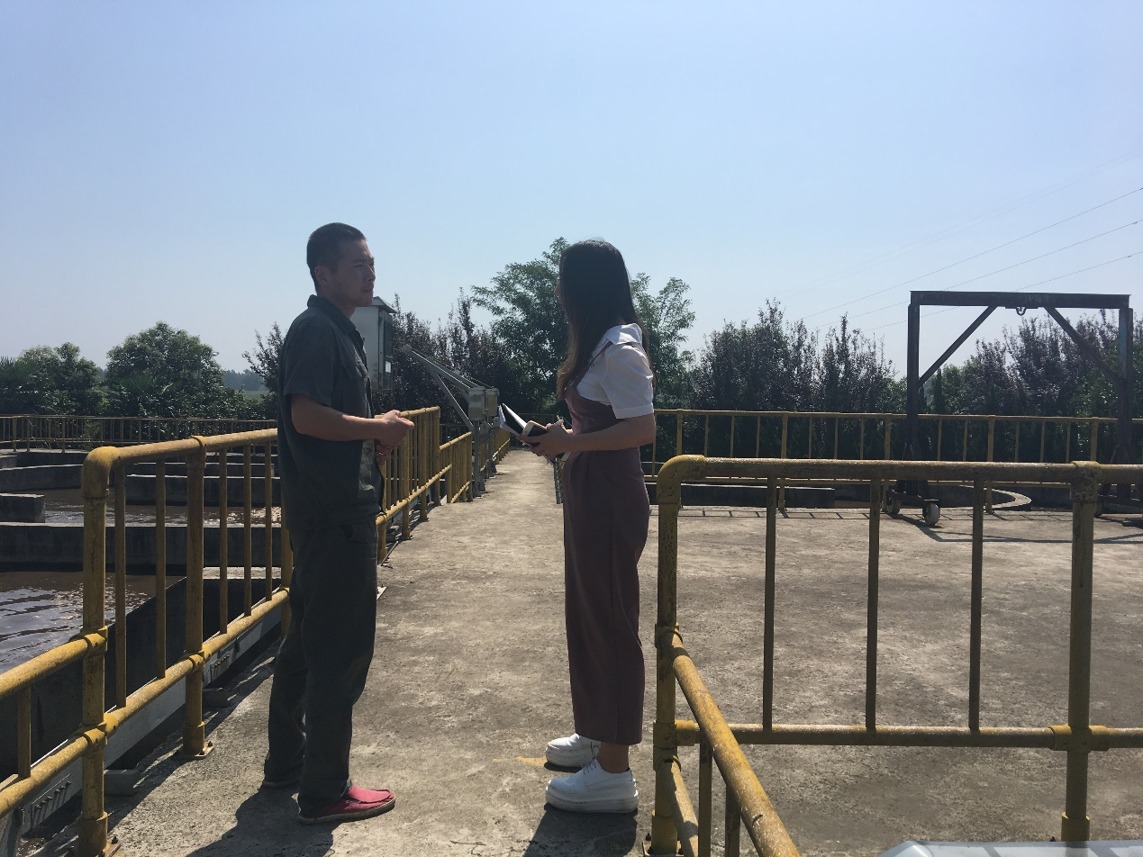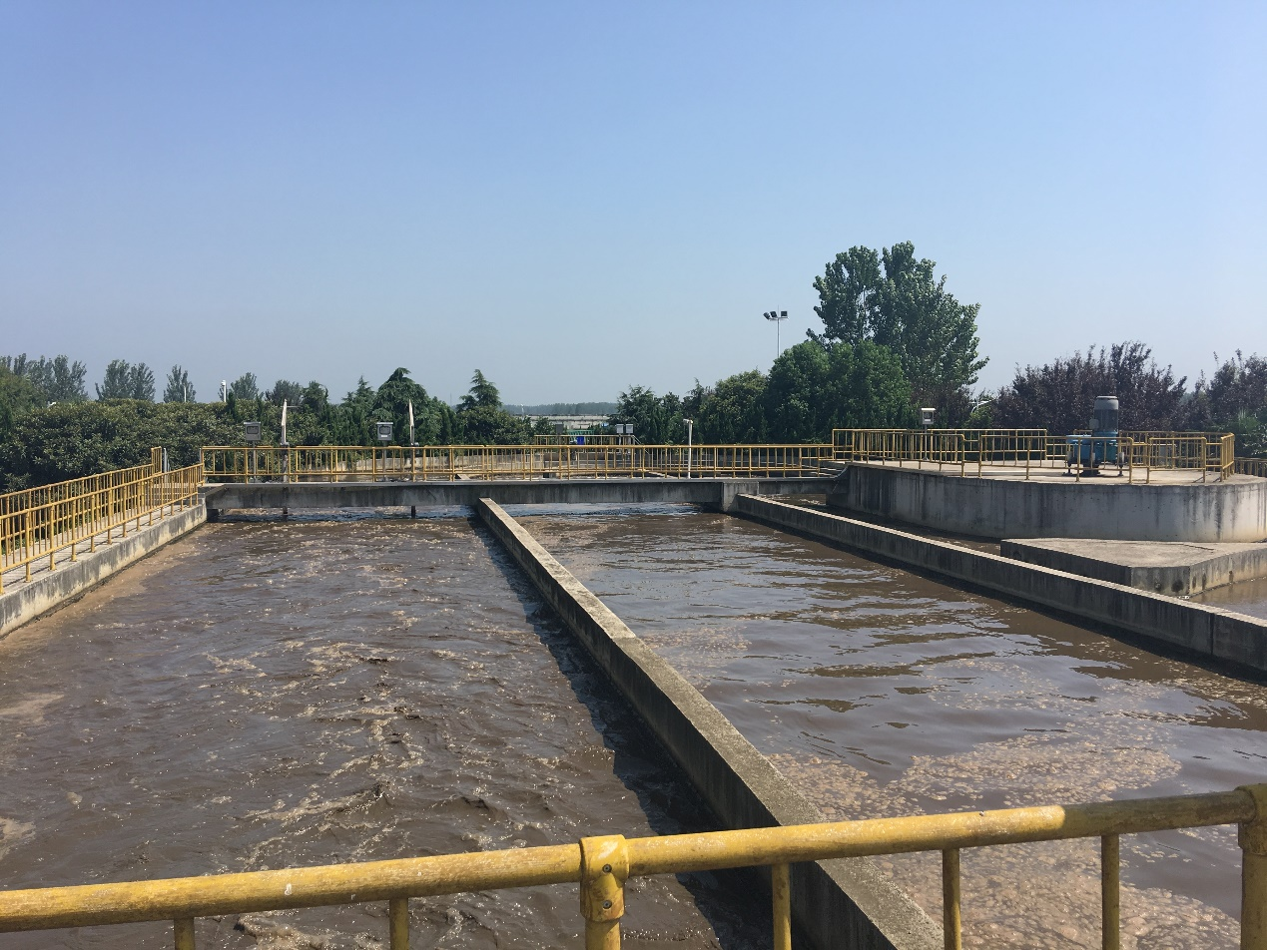

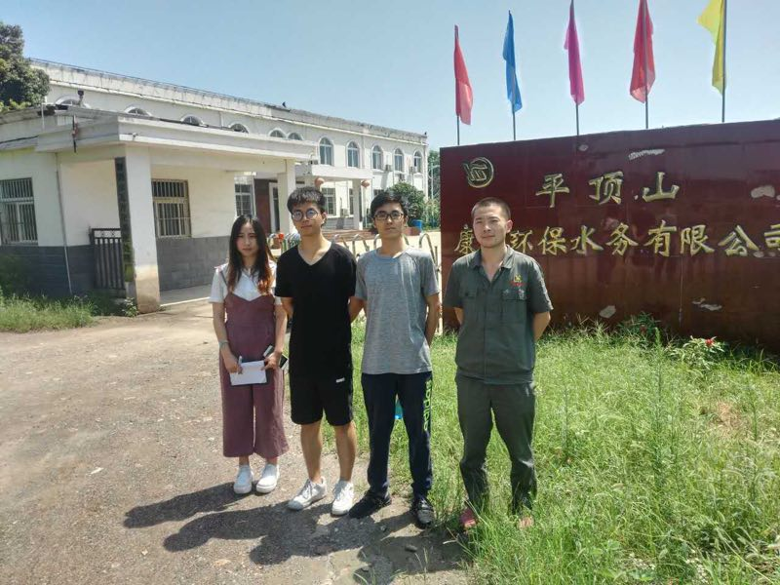

At the same time we were told that mixed bacteria is mainly used in the process of the treatment of domestic sewage, so we hope that we can have a chance to be able to put our yeast into the bacteria to treat sewage, which requires a detector.

To solve this problem, we should come up with a method that allow people test the content of heavy mental and when the components are higher than the standard, the settling process can be started. So we put promoter induced by copper into our gene route, so that when the content of copper is higher than the standard, the gene route can start.

## Tolerance issues: steel companies

Next, with our own ideas, we communicated with technical staffs from the pollution department of Hebei Iron and Steel Group Wugang company, Henan Province. (China's first base of thick steel plate production and scientific research. The main bearing frame of The Nest, Chongqing Chaotianmen Bridge and The Shanghai Central Building's are produced in this company). They led us to visit their cycle industrial wastewater treatment equipment, and they told us that generally the industrial wastewater is discharged to a sewage pool at first, then they will carry out the treatment of heavy metal ions. General strain can not tolerant such heavy metal content in industrial sewage, and the treatment using microbial requires oxygen and nutritional conditions. Therefore, we plan to improve the tolerance of bacteria, and we proposed that if Our strains can meet the requirements, they are willing to make their sewage pool be our first batch of test.

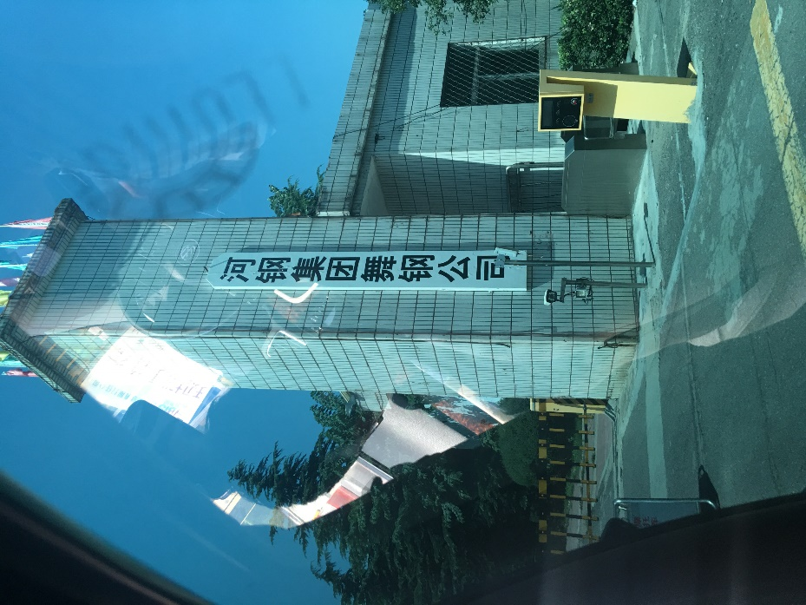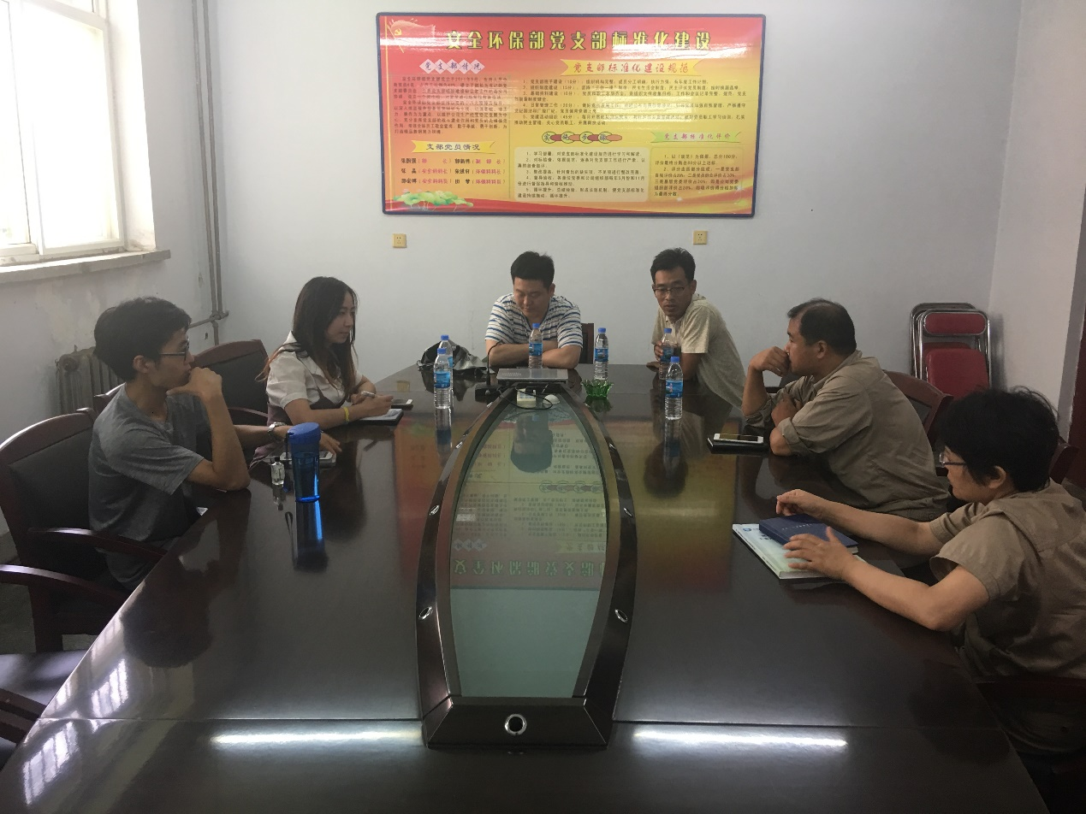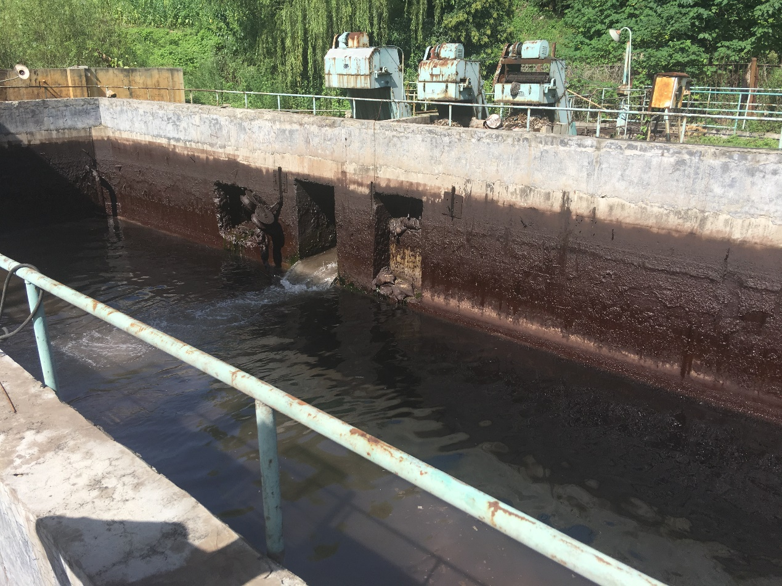

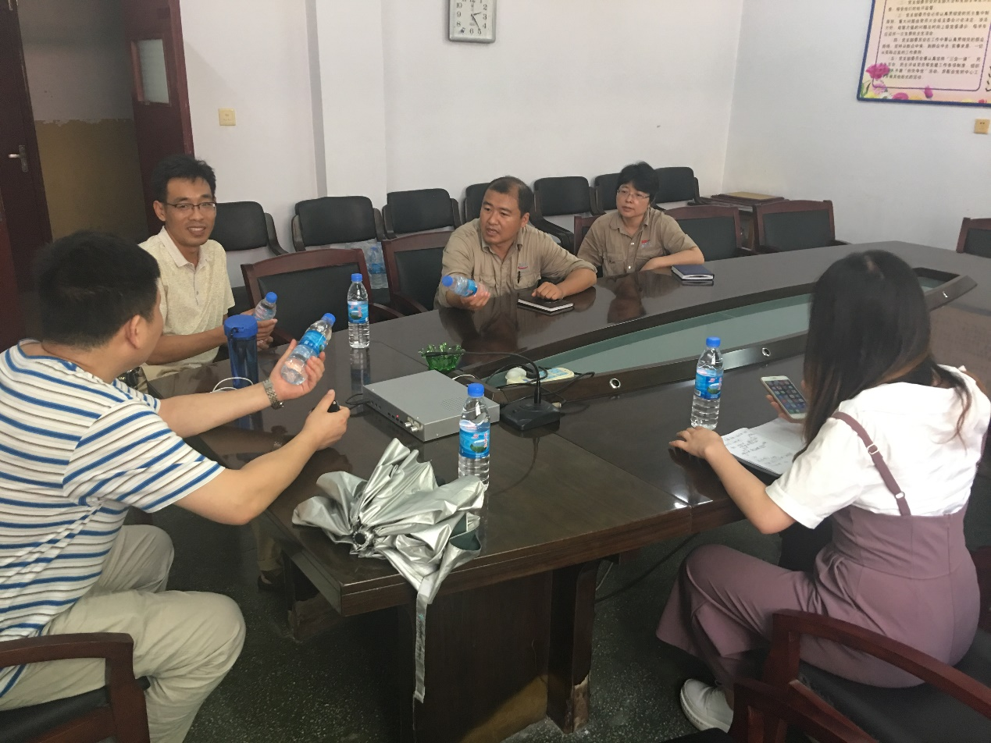

However, the tolerance of natural yeast to copper ions and cadmium ions conditions can not be able to put into production. Improving the tolerance and competitiveness of yeast to heavy metals is a necessary condition for our project.

Improving the growth of yeast in high concentrations of heavy metal ions is the key part to the application in production. We chose the cre-loxp system to rapidly evolve Saccharomyces cerevisiae to improve its resistance to copper and cadmium ions. The cre-loxp system utilizes the cre enzyme and the loxp site on the chromosome to cause the gene to be replicated, inverted, displaced and deleted, which is semi-rational changing of the chromosome structure. The modification of the gene depends on the direction of the loxp site. When in the same direction, the gene between sites will be deleted. On the contrary when in the reverse direction, the gene in the locus will flip. The genes located on different chromosomes may also be translocated. Based on artificial synthetic chromosome No.5 and No. 10, we used the loxpsym site inserted between the genes of the chromosome to turn on the recombination system through the cre enzyme. The difference between the loxpsym locus and the traditional loxp site is that the special palindromic structure of loxpsym locus will cause the possible structural changes of chromosomes. The strains with high concentration of metal ions will be selected under different concentrations of metal ions. So that the biological treatment of heavy metal pollution is more feasible.

## Cooperate with the government and the Environmental Protection Agency

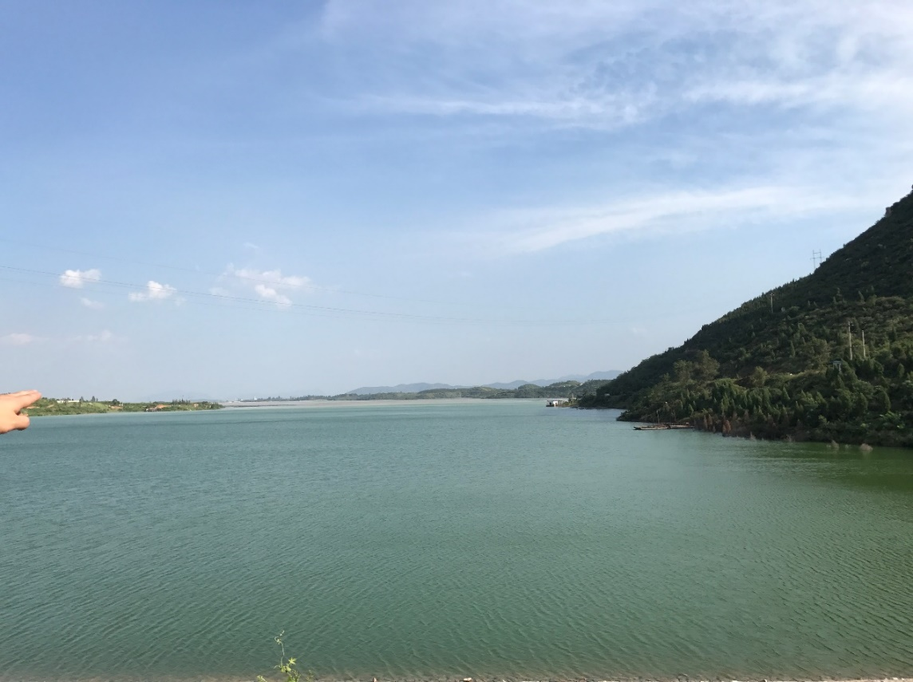In the end, we brought our results to an iron ore factory belongs to Anshan Iron and Steel Group in Henan Province and Zhongtiaoshan Nonferrous Metal Company in Shanxi Province, hoping to find the source of pollution and deal with the pollution from there. Their staffs told us that the main way of emissions in China is now through the discharging to the tailings.



We contacted the Shanxi Provincial Environmental Protection Bureau, the staffs are very supportive of our ideas, so they sent a full-time staff to lead us to Shanxi's largest copper mine, where we understand the existence of tailings. The Tailings is a place that collect the sewage specially. Because of the high cost and long period of treatment, the EPA generally does not deal with it. However, it can be harmful for the environment. So we hope that in the future we can utilize our yeast here.

Tailings deal with heavy metals by means of physical filtration. The processing intensity is not enough and there also exists harm to the environment. Generally the Environmental Protection Agency will take over the pollution, then outsource it to the heavy metal processing company to treat the pollution. At the same time we were informed that if the tailings is handled properly, there will be chances to create a huge wealth by re-extract the heavy metal here. We gave them a suggestion that they are supposed to consider withdrawing the water from the tailings reservoir and using our Saccharomyces cerevisiae to handle the heavy metals remaining in the tailings reservoir. At the same time we consulted the Beijing, Shanxi, Henan Environmental Protection Bureau and their counterparts in the outsourcing company, Zhongke Dingshi Non-ferrous Metal Company. This company had a nice response on our results, and they are willing to be our first test point if our experiment reached the point of maturity.

## Multi - party communication and self – examination

We also participated in the Fourth CCiC conference. At the meeting, we exchange our ideas and share our experiment with other teams, and received questions raised by them: 1. Whether the synthetic yeast will mate with natural yeast after delivered in nature, which results in gene integration. 2. It will be better If we can make the original copper detection switching device switch on and off automatically according to the concentration of copper ions.

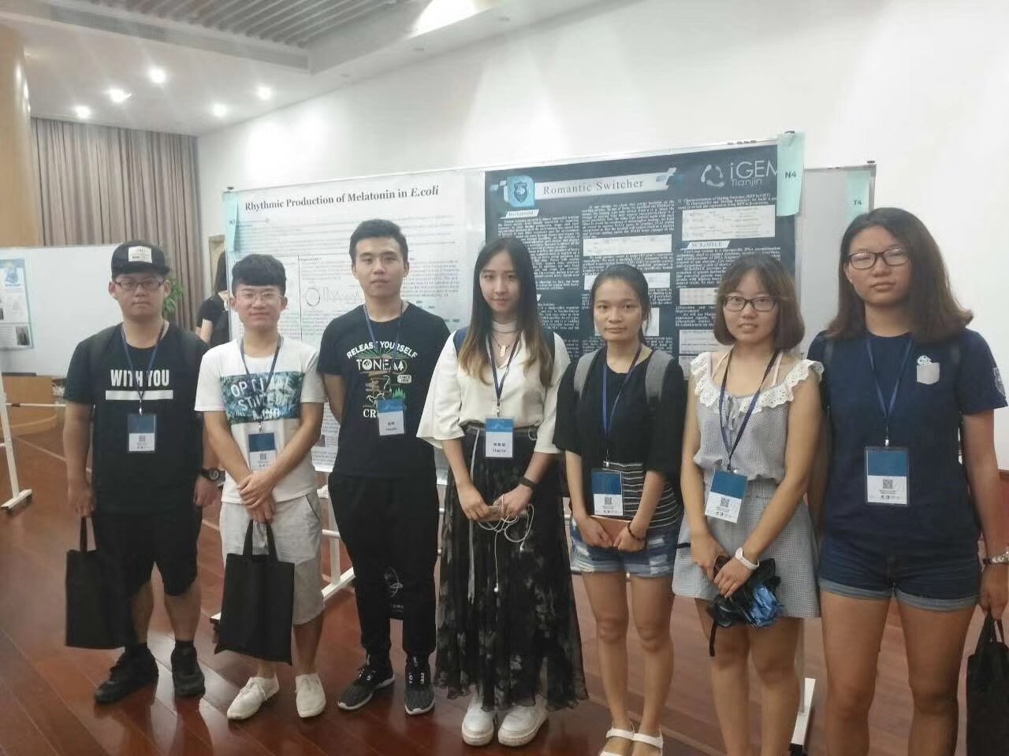

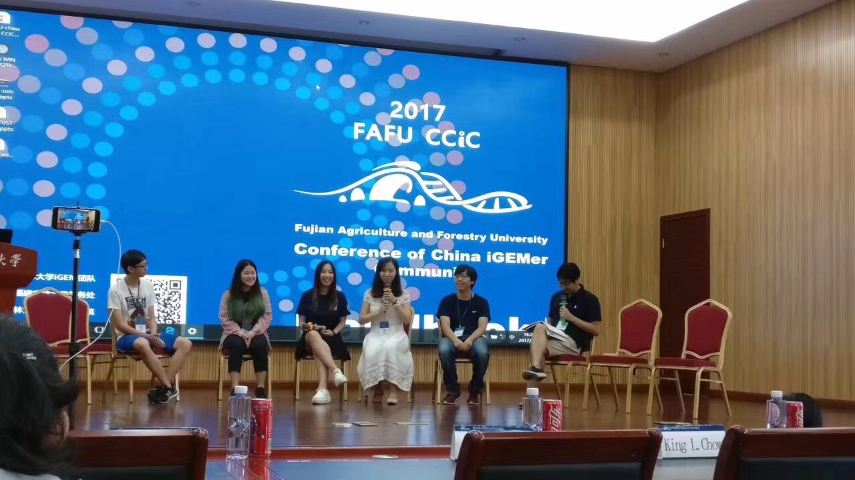

At the same time, we talked about our ideas and breed to many biotech companies, and mentioned that we are participating in this competition, requesting them to evaluate and analyze our project, and if our project is good enough to get some funds or reagents on the funding from them. I'm glad we finally found five companies that are willing to provide us with a total of 70,000 RMB sponsorship and many reagent supports.